**DAILY ONLINE ACTIVITIES SUMMARY**

|  |  |  |  |  |  |  |  |  |
| --- | --- | --- | --- | --- | --- | --- | --- | --- |
| **Date:** | **24-06-2020** | | | | | **Name:** | **D Jasmine Joyline** | |
| **Sem & Sec** | **VI Sem A** | | | | | **USN:** | **4AL17CS024** | |
| **Online Test Summary** | | | | | | | | |
| **Subject** | | **-** | | | | | | |
| **Max. Marks** | | **-** | | **Score** | | | **-** | |
| **Pre-placement Training Summary** | | | | | | | | |
| **Course** | 1.Java and J2EE2. Datastructures | | | | | | | |
| **Certificate Provider** | | | **-** | | **Duration** | | | **4hr** |
| **Coding Challenges** | | | | | | | | |
| **Problem Statement:**  Write a Java Program. | | | | | | | | |
| **Status:Completed** | | | | | | | | |
| **Uploaded the report in Github** | | | | | **Yes** | | | |
| **If yes Repository name** | | | | | <https://github.com/alvas-education-foundation/D_Jasmine_Joyline/tree/master/daily_progress> | | | |
| **Uploaded the report in slack** | | | | | **Yes** | | | |

Online Test Details:

-

Online Training Details:

Attended class on the topic Java and J2EE from 9am to 11am

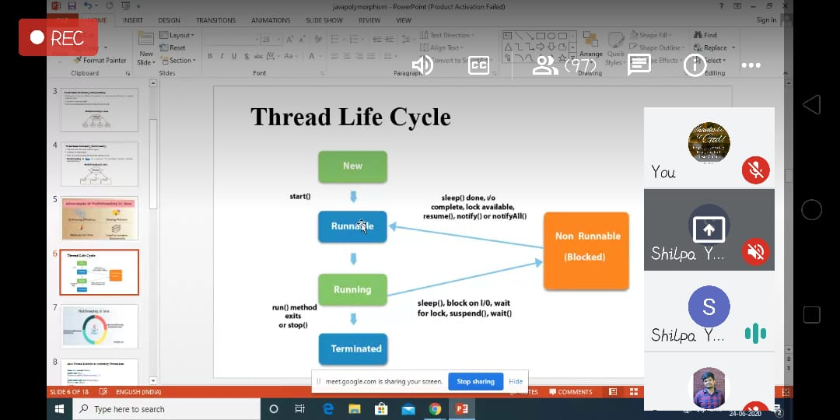

Attended class on the topic Datastructures from 11am to 1:30pm

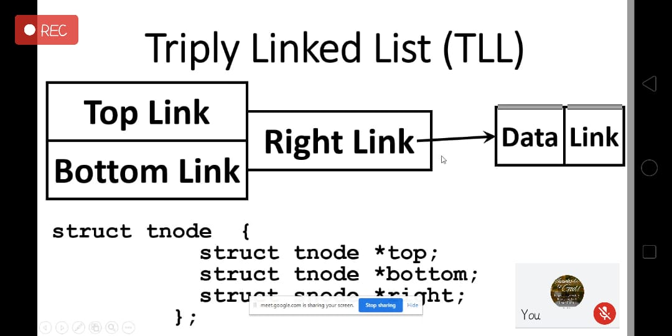

Coding Challenges Details:

Write a Java Program.

[Create a class named 'Shape' with a method to print "This is This is shape". Then create two other classes named 'Rectangle', 'Circle' inheriting the Shape class, both having a method to print "This is rectangular shape" and "This is circular shape" respectively. Create a subclass 'Square' of 'Rectangle' having a method to print "Square is a rectangle". Now call the method of 'Shape' and 'Rectangle' class by the object of 'Square' class.]

